ASSIGNMENT-2

Task-1:

write a python program that reads a list of numbers and calculates mean,maximum and minimum values.

Code and Output:

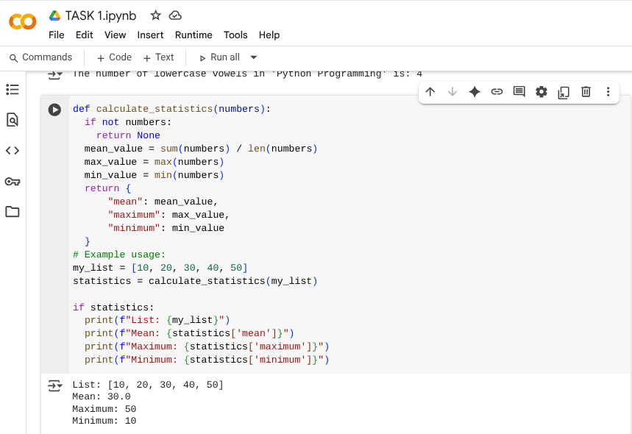

Explanation:

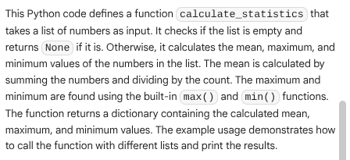

Task-2:

write a python function that checks the given number is an Armstrong or not.

Comparision between gemini and copilot-

Gemini:

Code and Output:

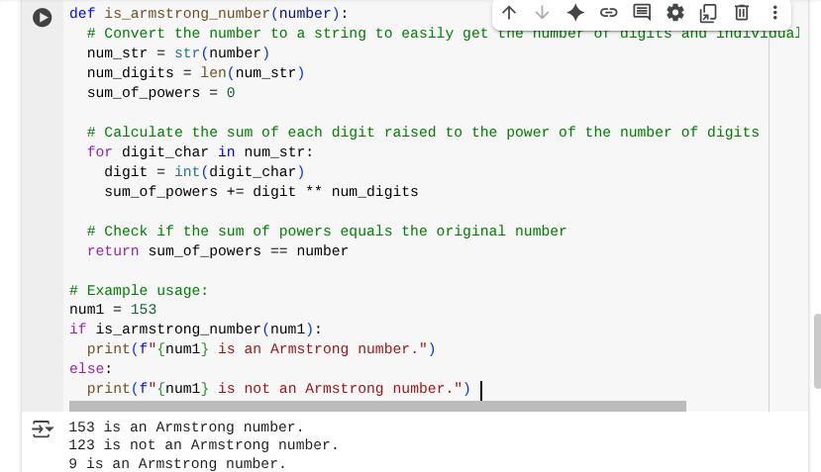

Explanation:

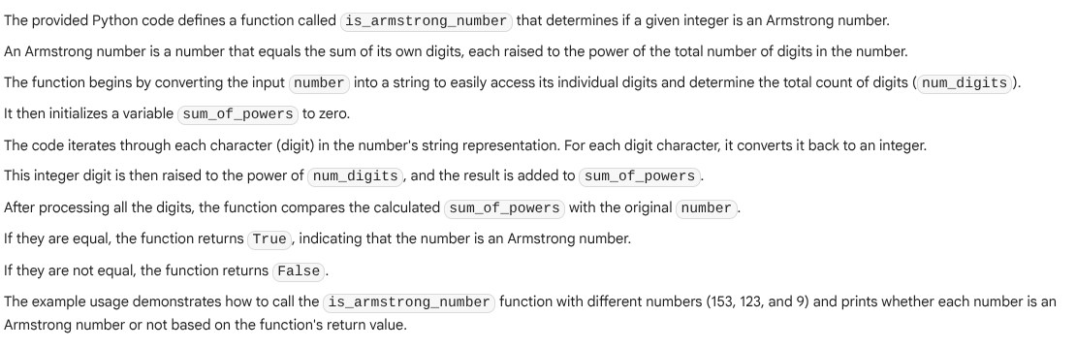

Copilot:

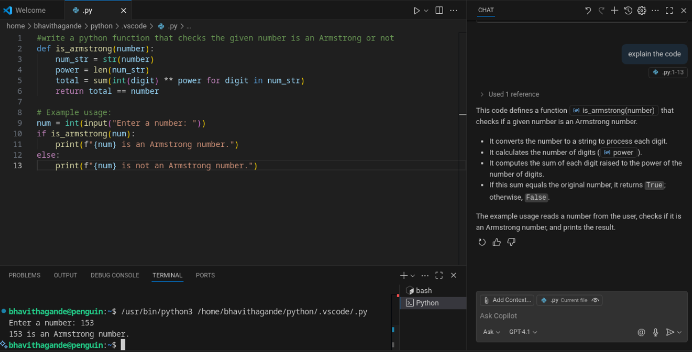

Task-3:

Code,Output and Explanation:

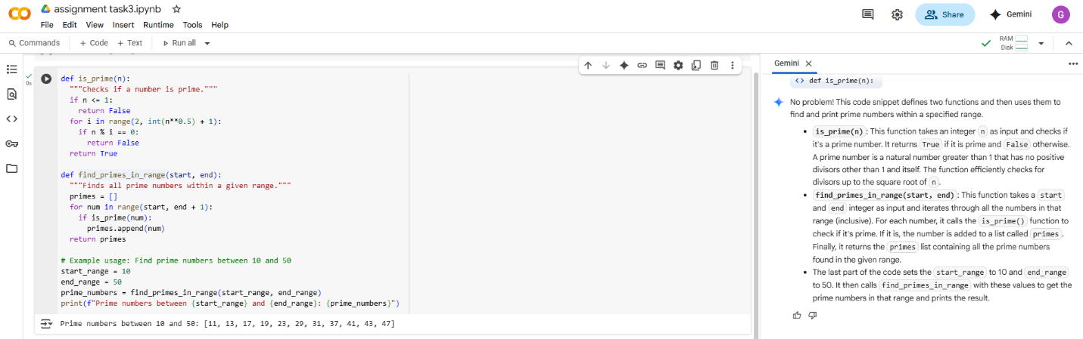Task-4:

Code and Output:

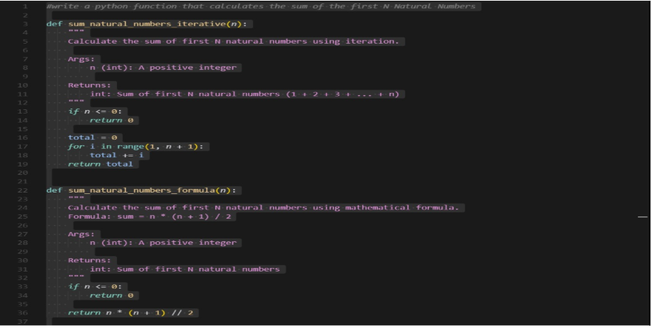

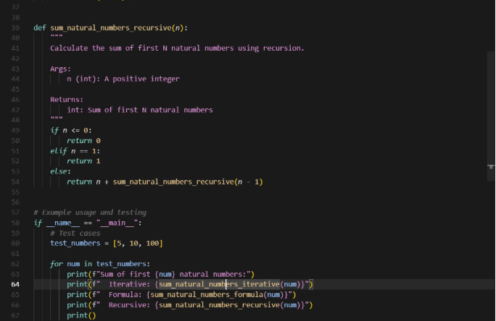

Explanation:

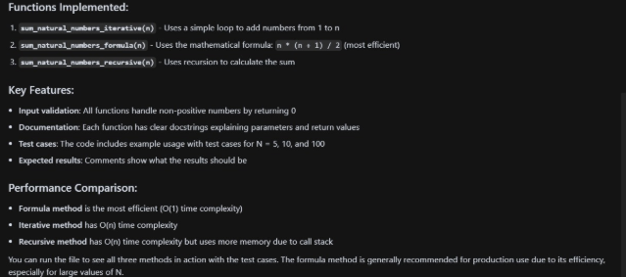

Task-5:

Code,Output and Explanation:

